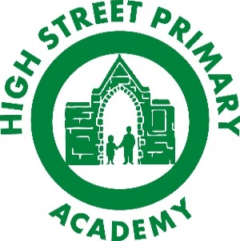
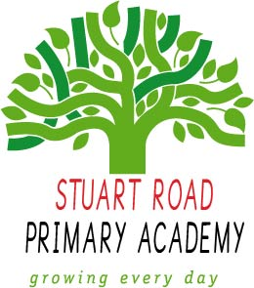
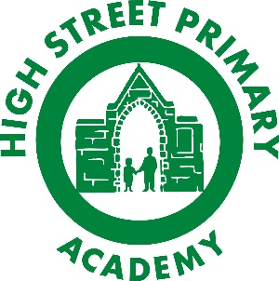
High Street Primary Academy
Home Learning
Electric Eels (Year 5/6) Autumn 2
Theme: The Myth Atlas
To get the most out of your home learning you must:
Complete the ‘daily tasks’ every day.
Select another task of your choice to complete each week.
We look forward to sharing your completed work in school.
Theme
- Choose a myth and create a fact file about its country of origin.
- Write a dictionary of geographical vocabulary that we have been learning about (human/physical geography, longitude, latitude, equator, etc)
- Create a comic strip of a chosen myth.
- Create your own mythical creature. Can you draw/paint a picture of them? What about a 3D model made from junk? Create a fact file to go with your creature.

Creative Writing
- Write your own version of a well-known myth. You could use http://myths.e2bn.org/mythsandlegends/ for inspiration.
- Write a well-known myth from the point of view of the villain: perhaps the medusa that Hercules faces isn’t evil after all!
- Write a diary entry from the perspective of a chosen character.
- Create a fact-file about a chosen mythical creature from your favourite myth.
- Write a newspaper report about the actions of a chosen mythical hero.

Maths
- Write a 12 question quiz on the topic of ordering numbers to one million – don’t forget to include the answers!
- Can you write your date of birth in Roman numerals? What about your friends and family?
- Create interesting word problems involving all operations: addition, subtraction, multiplication and division.
- Write a 12 question quiz on the topic of positive and negative numbers – don’t forget to include the answers!

Visit
www.mymaths.co.uk
www.topmarks.co.uk/maths-games/hit-the-button
https://ttrockstars.com

Daily tasks
- Read your reading book aloud to an adult and sign in your home reading record.
- Practise your times tables and division facts.

