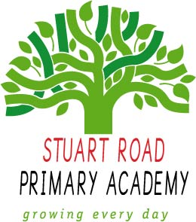
High Street Primary Academy
Home Learning
Electric Eels (Year 5/6) Spring 1
Theme: It’s a Wild, Wild World
To get the most out of your home learning you must:
Complete the ‘daily tasks’ every day.
Select another task of your choice to complete each week.
We look forward to sharing your completed work in school.
Theme
- Follow these instructions to make your own volcano! http://www.sciencefun.org/kidszone/experiments/how-to-make-a-volcano/ Why not use paper mache to make a volcano structure around the bottle? Take photos to share with us!
- Which shapes/structures are the strongest? How do you know? Investigate and record/report your findings.
- Research the different ways that individuals and communities can be supported after a natural disaster. Make a poster persuading people to help.
- Draw and label a diagram of the different parts of a volcano.

Creative Writing
- Write your own newspaper report of an event that has happened in the news (e.g wildfires in Australia)
- Choose a type of natural disaster (earthquake, tsunami, volcano eruption, flood, etc) and write an explanation of why they occur. Don’t forget to include labelled diagrams!
- Create a leaflet to advise people on how to prepare for and stay safe during an earthquake.
- Write a diary entry from the perspective of someone who has survived a natural disaster.

Maths
- Write an improper fraction and find 6 different ways to write it. You can use mixed numbers and equivalent fractions.
- Create a poster explaining how to add and subtract fractions. You could choose fractions that have the same or different denominators.
- Write a range of word problems involving fractions that can be given to the rest of the class as a quiz to test their understanding.

Visit
www.mymaths.co.uk
www.topmarks.co.uk/maths-games/hit-the-button
https://ttrockstars.com

Daily tasks
- Read your reading book aloud to an adult and sign in your home reading record.
- Practise your times tables and division facts.

