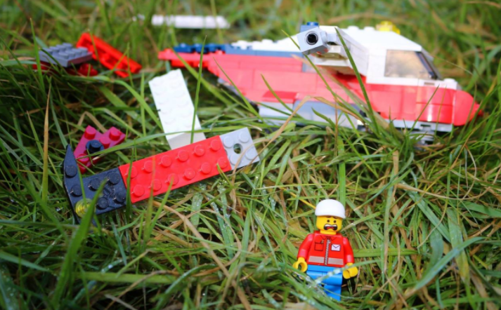
Crash!

Activity 1: Story starter!
Continue the story. Use adventurous adjectives, expanded noun phrases, similes, metaphors, subordinating conjunctions and a range of sentence openers.
Lawrence was injured, afraid, lost and completely alone. He had been thrown viciously from the aircraft after the flock of birds had attacked the propellers.
As he laid there, listening to his racing heart, he wondered what would happen to him.
How would he make it out alive?

Activity 2: Question time!
Answer all of the questions as best you can. If you don’t want to write them, you can record yourself answering them and email the video back to the school office.
- How has the helicopter crashed?
- What do you think he should try to do next?
- Who might be able to help in this situation?
- What do you think you would do if you were in a similar situation?
- Why do you think he is afraid?
- What might he be afraid of?

Activity 3: Sentence challenge!
Using an adverb at the beginning of a sentence makes your writing more interesting.
Some examples, cautiously, anxiously, happily, silently.
Add an adverb at the beginning of these sentences:
_________, he wondered where he was.
________, the helicopter was whirring.
Now write your own sentence and remember to use an adverb at the beginning.

Activity 4: Sick sentences!
These sentences are ‘sick’ and need help to get better. Can you help? Edit the sentences to make them more exciting.
There had been a crash.
The helicopter was broken.
Lawrence was hurt.

Activity 5: Perfect picture!
Draw a picture of what Lawrence might have seen before the helicopter crashed.

