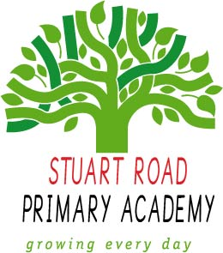
High Street Primary Academy
Home Learning
Electric Eels (Year 5/6) Autumn 1
Theme: Once upon a time…
To get the most out of your home learning you must:
Complete the ‘daily tasks’ every day.
Select another task of your choice to complete each week.
We look forward to sharing your completed work in school.
Theme
- Carry out independent research about an inspirational person – what makes them inspirational? What are they well-known for? What was their early life like?
- Write a biography about your chosen inspirational person.
- Create a comic strip of a chosen fairy-tale.
- Create your own villainous character and create a fact-file about them.
- Make a lift-the-flap storybook telling the story of your created villain.

Maths
- Write a 20 question quiz on the topic of Number and Place Value. Use MyMaths to give you some ideas.
- How can I show my knowledge of the 4 operations? e.g. Create some problems and puzzles using the 4 operations.
- What are Roman numerals? Write a set of at least 25 calculations using Roman numerals.
- Create interesting word problems involving all operations: addition, subtraction, multiplication and division.

Visit
www.mymaths.co.uk
www.topmarks.co.uk/maths-games/hit-the-button
https://ttrockstars.com

Creative Writing
- Write your own version of a well-known fairy-tale (such as Little Red Riding Hood, Jack and the Beanstalk, etc)
- Write a well-known fairy-tale from the point of view of the villain: perhaps the witch in Hansel and Gretel isn’t evil after all!
- Write a diary entry from the perspective of a chosen character (the big bad wolf, the witch, etc)
- Create a fact-file about a villain from your favourite traditional tale.
- Write a newspaper report about the actions of a chosen villain.

Daily tasks
- Read your reading book aloud to an adult and sign in your home reading record.
- Practise your times tables and division facts.

