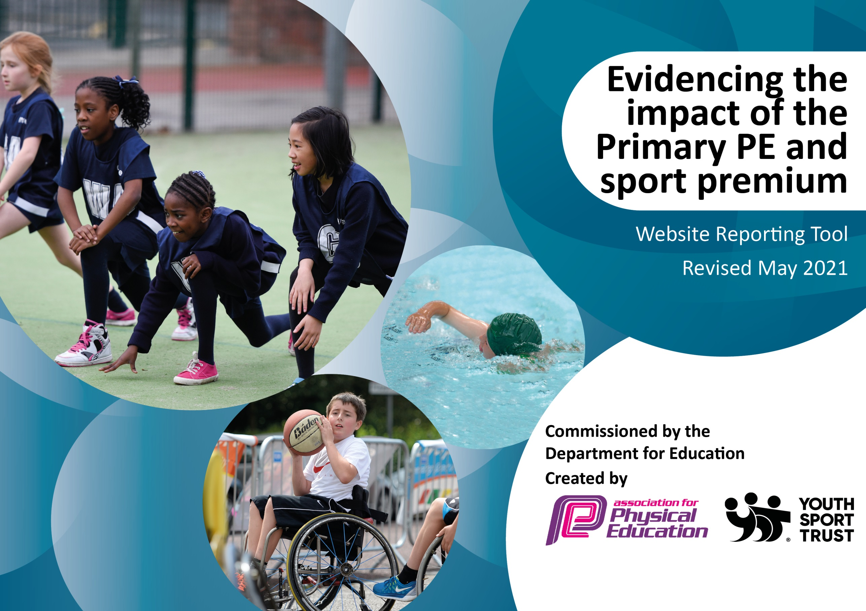

It is important that your grant is used effectively and based on school need. The Education Inspection Framework (Ofsted 2019 p64) makes clear there will be a focus on ‘whether leaders and those responsible for governors all understand their respective roles and perform these in a way that enhances the effectiveness of the school’.

Under the Quality of Education criteria (p41) inspectors consider the extent to which schools can articulate their curriculum (INTENT), construct their curriculum (IMPLEMENTATION) and demonstrate the outcomes which result (IMPACT).

To assist schools with common transferable language this template has been developed to utilise the same three headings which should make your plans easily transferable between working documents.

Schools must use the funding to make additional and sustainable improvements to the quality of Physical Education, School Sport and Physical Activity (PESSPA) they offer. This means that you should use the Primary PE and sport premium to:

- Develop or add to the PESSPA activities that your school already offer
- Build capacity and capability within the school to ensure that improvements made now will benefit pupils joining the school in future years
- The Primary PE and sport premium should not be used to fund capital spend projects; the school’s budget should fund these.
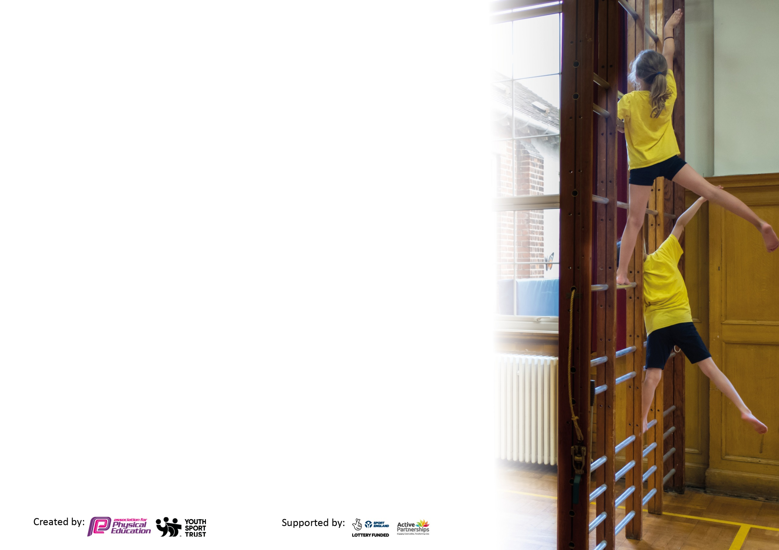
Please visit gov.uk for the revised DfE guidance including the 5 key indicators across which schools should demonstrate an improvement. This document will help you to review your provision and to report your spend. DfE encourages schools to use this template as an effective way of meeting the reporting requirements of the Primary PE and sport premium.

We recommend you start by reflecting on the impact of current provision and reviewing the previous spend.

Schools are required to publish details of how they spend this funding, including any under-spend from 2019/2020, as well as on the impact it has on pupils’ PE and sport participation and attainment by the end of the summer term or by 31st July 2021 at the latest.

We recommend regularly updating the table and publishing it on your website throughout the year. This evidences your ongoing self-evaluation of how you are using the funding to secure maximum, sustainable impact. Final copy must be posted on your website by the end of the academic year and no later than the 31st July 2021. To see an example of how to complete the table please click HERE.

Please note: Although there has been considerable disruption in 2020 it is important that you publish details on your website of how you spend the funding - this is a legal requirement.
Support for review and reflection - considering the 5 key indicators from DfE, what development needs are a priority for your setting and your pupils now and why? Use the space below to reflect on previous spend and key achievements and areas for development.

N.B. In this section you should refer to any adjustments you might have made due to Covid-19 and how these will influence further improvement.
Key achievements to date until July 2020: | Areas for further improvement and baseline evidence of need:
- Achieving the ‘Gold’ School Games Mark. | - Ensure that a range of appropriate equipment is available to deliver high-quality PE.

Did you carry forward any underspend from 2019-20 academic year into the current academic year? YES
Total amount carried forward from 2019/2020 £5,087.00
+ Total amount for this academic year 2020/2021 £16,980.00
= Total to be spent by 31st July 2021 £22,067.00

Meeting national curriculum requirements for swimming and water safety.

N.B Complete this section to your best ability. For example, you might have practised safe self-rescue techniques on dry land which you can transfer to the pool when school swimming restarts.
Due to exceptional circumstances priority should be given to ensuring that pupils can perform safe self rescue even
if they do not fully meet the first two requirements of the NC programme of study.
What percentage of your current Year 6 cohort swim competently, confidently and proficiently over a distance of at least 25 metres?  N.B. Even though your pupils may swim in another year please report on their attainment on leaving primary school at the end of the summer term 2021.  Please see note above. | 75%
What percentage of your current Year 6 cohort use a range of strokes effectively [for example, front crawl, backstroke and breaststroke]?  Please see note above. | 25%
What percentage of your current Year 6 cohort perform safe self-rescue in different water-based situations? | 25%
Schools can choose to use the Primary PE and sport premium to provide additional provision for swimming but this must be for activity over and above the national curriculum requirements. Have you used it in this way? | Yes/No

Action Plan and Budget Tracking
Capture your intended annual spend against the 5 key indicators. Clarify the success criteria and evidence of impact that you intend to measure to evaluate for pupils today and for the future.

Academic Year: 2020/21 |  | Total fund allocated: £22,067.00 |  | Date Updated: 12/07/2021
Key indicator 1: The engagement of all pupils in regular physical activity – Chief Medical Officers guidelines recommend that primary school pupils undertake at least 30 minutes of physical activity a day in school |  |  |  |  |  | Percentage of total allocation:
 |  |  |  |  |  | 40%
Intent | Implementation |  |  |  | Impact
Your school focus should be clear what you want the pupils to know and be able to do and about  what they need to learn and to  consolidate through practice: | Make sure your actions to achieve are linked to your intentions: |  | Funding allocated: |  | Evidence of impact: what do pupils now know and what can they now do? What has changed?: | Sustainability and suggested next steps:
Ensure that pupils participate in adult-led physical activity during break times and lunch times. | Utilise the services of TGS Coaching to provide high-quality sports coaches to the children at lunchtimes to lead competitive and highly engaging sporting activities.  Employ play leaders to provide physical activity opportunities. |  | £2,535  £6,375 |  | Through the utilisation of external sports coaches, as well as our own mealtime assistants, children have positive active sporting opportunities every day during break and lunch time. Children are enthused by the sports provision and excited to participate. | Further utilise TGS Coaching staff, as well as PSSP staff, to provide a wider range of sporting opportunities before and after school, which contribute to children’s 30 minutes of daily physical activity.

Key indicator 2: The profile of PESSPA being raised across the school as a tool for whole school improvement |  |  |  | Percentage of total allocation:
 |  |  |  | 41%
Intent | Implementation |  | Impact
Your school focus should be clear what you want the pupils to know and be able to do and about  what they need to learn and to  consolidate through practice: | Make sure your actions to achieve are linked to your intentions: | Funding allocated: | Evidence of impact: what do pupils now know and what can they now do? What has changed?: | Sustainability and suggested next steps:
Replace and replenish, where necessary, PE equipment and resources to support the delivery of the PE National Curriculum.  Broaden the range of PE equipment available to children and staff, and ensure that enough equipment is available to run effective PE sessions.  Provide appropriate means to store equipment to ensure that it is well looked after and kept in good condition. | Conduct an audit to ascertain the number and quality of existing PE resources.  Purchase new resources where necessary to support the delivery of the PE curriculum, as well as the delivery of quality physical activity during break times and lunch times. | £5,512 | Children and staff now have access to a range of PE equipment, with enough equipment to maximise participation and time during PE lessons. | Ensure that equipment is stored appropriately to allow for longevity of use.
Provide children access to new sporting opportunities, experiences, and resources. | Continued membership with Plymouth Schools’ Sports Partnership (PSSP)- allowing access to competitions and sporting experiences such as indoor rowing. | £3,500 | Children have enjoyed access to sporting events and opportunities provided by the PSSP. KS2 children participated in a day of rowing, competing virtually with other schools. | Continue to subscribe to the PSSP in order to provide a wider range of competitions and sporting opportunities.

Key indicator 3: Increased confidence, knowledge and skills of all staff in teaching PE and sport |  |  |  | Percentage of total allocation:
 |  |  |  | 4%
Intent | Implementation |  | Impact
Your school focus should be clear | Make sure your actions to | Funding | Evidence of impact: what do | Sustainability and suggested
what you want the pupils to know | achieve are linked to your | allocated: | pupils now know and what | next steps:
and be able to do and about | intentions: |  | can they now do? What has
what they need to learn and to |  |  | changed?:
consolidate through practice:
Provide opportunities for teachers to incorporate PE and sports into the teaching of English and maths. | Subscribe to the ‘Teach Active’ online resources, which provides access to lesson plans to deliver core subjects through physical activity. | £975 | Children have solidified their understanding of English and maths concepts through physical activity. | Continue to make use of Teach Active resources to deliver English and maths content.

Key indicator 4: Broader experience of a range of sports and activities offered to all pupils |  |  |  | Percentage of total allocation:
 |  |  |  | 0%
Intent | Implementation |  | Impact
Your school focus should be clear | Make sure your actions to | Funding | Evidence of impact: what do | Sustainability and suggested
what you want the pupils to know | achieve are linked to your | allocated: | pupils now know and what | next steps:
and be able to do and about | intentions: |  | can they now do? What has
what they need to learn and to |  |  | changed?:
consolidate through practice:
Provide opportunities for children to access a wider range of sporting activities. | Utilise the PSSP, their coaches and equipment, to offer different sporting opportunities (opportunities will be limited due to COVID), such as indoor rowing and Bikeability. | Inclusive of PSSP membership. | Children participated in an indoor rowing event, competing against other schools in Plymouth. | Continue to look for opportunities to offer our children a varying range of non-traditional sports.

Key indicator 5: Increased participation in competitive sport |  |  |  | Percentage of total allocation:
 |  |  |  | 0%
Intent | Implementation |  | Impact
Your school focus should be clear | Make sure your actions to | Funding | Evidence of impact: what do | Sustainability and suggested
what you want the pupils to know | achieve are linked to your | allocated: | pupils now know and what | next steps:
and be able to do and about | intentions: |  | can they now do? What has
what they need to learn and to |  |  | changed?:
consolidate through practice:
Allow children to compete with children from other schools/settings in a range of sporting activities. | Utilise the PSSP to allow children the opportunity to complete (virtually) with other schools in different sports. | Inclusive of PSSP membership. | Children participated in an indoor rowing event, competing against other schools in Plymouth. | Continue to look for opportunities to offer our children a varying range of non-traditional sports.
Total allocation: £22,067
Final expenditure: £18,897
Amount to carry forward 2021/2022: £3,170

Signed off by
Head Teacher: | Steph Blake
Date: | 30/07/2021
Subject Leader: | Adam Green
Date: | 12/07/2021

