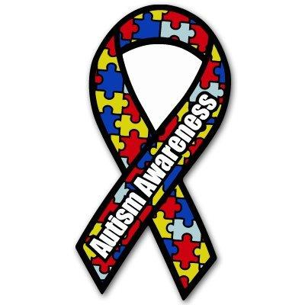

**Celebrate Autism Awareness week with CAMHS!**

***Monday April 1st 2019***

***12:30 – 3 pm at The Terraces, Mount Gould Hospital***

**Drop-in event for school staff, parents and families to learn more about local support and services**

**Confirmed so far:**

* **Friends and Families of Special Children**
* **Routeways**
* **National Autistic Society – Plymouth Adult Aspergers Branch**

**…plus members of the CAMHS Neuro-Developmental team to answer your questions.**

