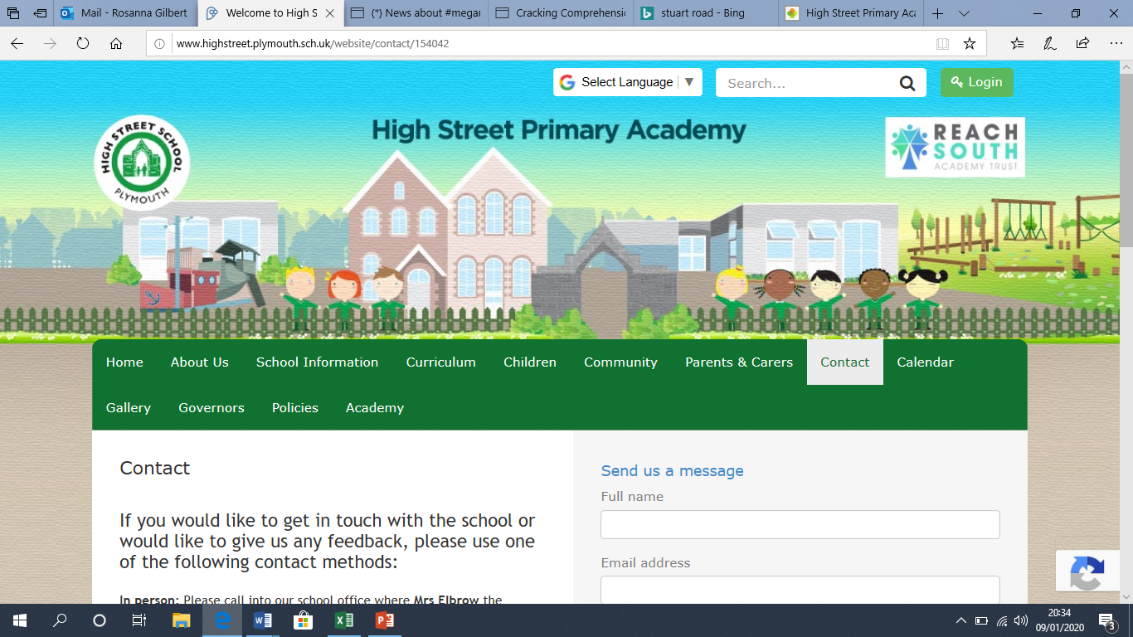 

**To get the most out of your remote learning you should:**

Complete the ‘daily tasks’ every day. Select another ‘theme’ task of your choice to complete each day. Please use the exercise book to record anything that you do.

**High Street Primary Academy**

**Remote Learning - Foundation/Year 1**

**Theme: The Gingerbread Man**

**Daily tasks**

1. Read to your child
2. Read and write green words
3. Practice writing your name
4. Practice writing Set 1 sounds
5. Write numbers 0 to 10 correctly
6. Play Numbots
7. Sing number songs and rhymes
8. Complete a puzzle
9. Play a board game with your family
10. Do some physical exercise indoors

**Wellbeing**

1. Your child will be missing their friends and teachers – can they draw a picture or write a letter for their friend or teacher to bring in when they return to school?
2. Keep a daily routine going as much as possible
3. Connect online with family and friends – if you’re in touch with other parents from your child’s class, can you come up with some ideas together for staying connected?
4. Make a boredom jar - ask your child what their favourite indoor activities are and use them to make a lucky dip or boredom jar. Write their ideas down on strips of paper and keep them in any container you’ve got, such as a bag, bowl, jar or hat. In moments of boredom or struggle, invite them to choose something they know they enjoy doing

**Theme: The Gingerbread Man**

1. Design your own Gingerbread Man
2. Draw pictures from the story of The Gingerbread Man
3. If you have the ingredients, cook Gingerbread Men – if you haven’t, can you bake something else?
4. Write instructions on how to cook Gingerbread Men
5. Draw a Gingerbread Man – how many buttons can you put on him? (If you don’t have any buttons, you can use something else)
6. Write a letter to The Gingerbread Man, the little old woman or the little old man
7. Tell a grown-up the story of The Gingerbread Man using different voices for each character
8. Think of 5 words that rhyme with ‘man’ – draw pictures or write the words you think of
9. Lots of animals want to eat The Gingerbread Man! Draw a picture of you favourite animal from the story and write the name of the animal. You could draw a cat, a dog, a pig, a cow or a fox!
10. Draw a picture or make a model of The Gingerbread Man