****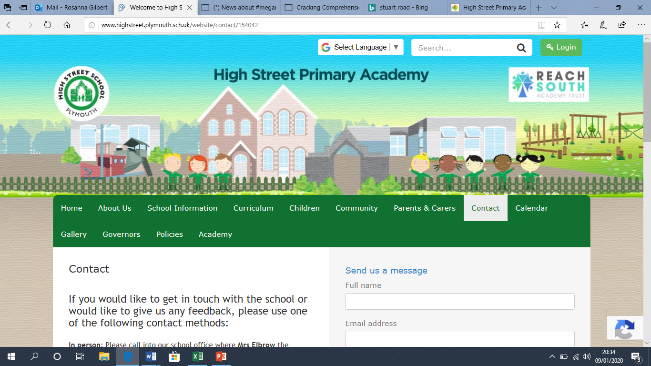**High Street Primary Academy**

**Starfish Class Home Learning WB: 06.04.20**

**We look forward to sharing your completed work in school.**

**Project**

* Make an Easter card for your family
* Design an Easter egg!
* Have a go at making Easter rice crispy cakes!

Spellings this week:

said

have

like

come

when

Practice writing these in a sentence e.g. I like chocolate Easter eggs.

**English**

**Maths**

- We have been looking at 2D shapes in school. (Circle, square, rectangle and triangle) Can you go on a shape hunt around the house? Make a record of all of the things in your home that are these shapes. E.g. a table may have a rectangle surface. For a challenge, you could investigate 3D shapes. Use you tube videos to help. Look at Cubes, Spheres, cuboids and pyramids.

Please continue to use the web links on the school class page- these will help children with their learning in a fun and exciting way!

**Daily reading**

*-* Read for at least 10 minutes every day! You can access the free eBooks from the links on our class webpage.

-

Practice your read, write, inc sounds using the online video clips on the class page. You should know set 1 and set 2 and should be learning set 3. Practice writing words with these sounds. Check the chart on the web page under week 2 learning.

-Share your favorite story with someone at home.

-Tell them why it is your favorite? Is it because of something that happens? Or is it because you like a character? It could even be because it is funny!

Over the week have a go at writing your favorite story! Remember your finger spaces, capital letters and full stops.

