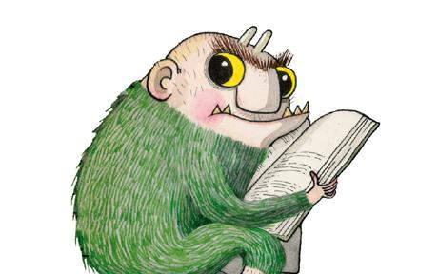 KS2 Writing Knowledge Organiser: Traditional Tales

Key Vocabulary
Introduction: describing the setting and main characters.
Build up: what happens next – how the story hint at what’s going to happen.
Dilemma: what the problem is within the story.
Resolution: how the problem is sorted out/resolved.
Ending:how the story ends.
Dialogue: what characters say - used to advance the action.
Simile/metaphor: figures of speech used to compare two things that aren’t alike but have something in common – used to add detail characters and settings
Repeated phrases: I’ll huff and I’ll puff… fe-fi-fo-fum…
Traditional Language: Once upon a time…, …and they lived happily ever after

Key Facts
Starting Out!
Extend It!
A traditional tale is a story that has been told and retold for many years and consequently becomes a story that almost everyone knows. Traditional tales are also referred to as fairy tales or fairy stories. They have no known author and have been passed from generation to generation through story telling. Most fairy tales have many different versions as each person who tells the story changes some details.
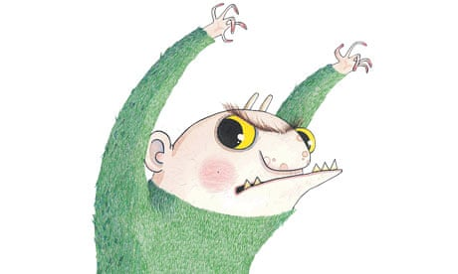

- Set in an imaginary land
- The story has a moral
- Tells us how people used to live in the past
- Includes an event or phrase that happens three times
- Settings include: magical kingdom, land far, far away, cottage, forest, wood
- Often being with ‘Once upon a time…’
- Love and magic are common themes
- Talking animals, princes and princesses
- Ending is usually ‘…happily ever after'.
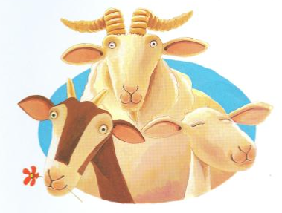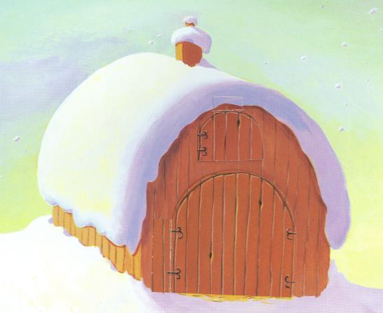

Animal characters with human characteristics.
Stresses themes such as: the value of cooperation, looking at problems from different viewpoints; rewards if lesson is learned.
Lessons may not be stated directly.
Problem which is usually overcome through kindness, courage and intelligence
Alternative openings using traditional language: Did you ever hear the story of… Far away and just as long ago… Far beyond the edges of the world….

- Name the five stages of a fairy tale.
- Compare characterisation from two different fairy tales by naming 2 similar characters
- Discuss what traditional language you might find in a fairy tale by listing 3 phrases you might see repeated.
- Explain why animals in fairy tales are given human characteristics. Name one animal and its human characteristics.
- Create an alternative title for your favourite fairy tale.
Congratulations – you have reached expert status!
Become an Expert! By the end of this unit I can…
TOP TIP: Always use a comma after your subordinate clause if it is at the beginning of the sentence.
Try to remember...The best pieces of writing use a mix of complex sentences, compound sentences and simple sentences.

