Key Vocabulary
Introduction: describing the setting and main characters.
Build up: what happens next – how the story hints at what’s going to happen.
Dilemma: what the problem is within the story.
Resolution: how the problem is sorted out/resolved.
Ending: how the story ends.
Dialogue: what characters say - used to advance the action.
Simile/metaphor: figures of speech used to compare two things that aren’t alike but have something in common – used to add detail to characters and settings
Cohesive device: words or phrases that are used to link different parts of a text together, creating a logical order
Synonym: a word that has a similar meaning to another word

KS2 Writing Knowledge Organiser: Myths

Myths always include:
Starting Out!
Extend It!

A myth is a traditional, ancient story that is fictional. Sometimes they are loosely based on a real event but, more often than not, it is a story that has been created to teach people about something very important and meaningful. Myths were often written to explain natural phenomena and quite often involved gods and fantasy creatures. Many myths have survived for a very long time, sometimes for thousands of years.

- An interesting setting, for example an island, a mountain, a desert
- A fantastical beast, for example a unicorn or a flying horse or mythical beast like Medusa
- A hero
- Objects to help the hero save the day, for example winged sandals, a shield, a sword
- Obstacles the hero has to complete/survive in order to rescue someone, for example return with the head of the beast, or collect the Golden Fleece.

Overarching theme of good versus evil and overcoming adversity.
Stresses themes such as: the value of cooperation, looking at problems from different viewpoints; rewards if lesson is learned.
Stories have a message or discussion point, usually about a problem that is overcome through kindness, courage or intelligence.
Myths don’t always have to have a happy ending – often a main character or loved one is killed off towards the end of the story.

Try to remember...The best pieces of writing use a mixture of sentence structures: of complex sentences, compound sentences and simple sentences.

- Identify the features of a myth.
- Recognise how stories change over time and the differences in culture and place.
- Explore and discuss differences between oral and written story telling.
- Identify a range of language structures and explain the impact on cohesion and meaning.
- Create my own myth using the identified features and language structures.
Congratulations – you have reached expert status!
Become an Expert! By the end of this unit I can… 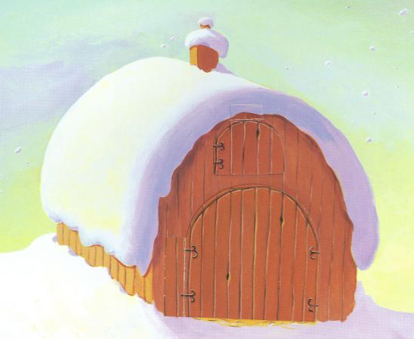

TOP TIP: Use adverbs and conjunctions to establish cohesion within paragraphs.

