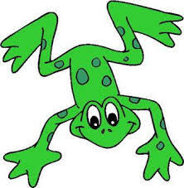

FRED GAMES

Speaking like Fred helps children to understand that words are made up of sounds. Use Fred Talk throughout the day to help children practise blending sounds together.

Fred says…

- Say: Fred says put your hands on your h-e-d. Ask children to repeat. Pause to allow children to jump in with the whole word and do the action.
- Say: h-e-d, hed. Ask children to repeat.

Repeat with: b-a-k, t-u-m, l-e-g, h-a-n-d, f-u-t, n-ee, r-u-n, s-k-i-p, h-o-p, s-t-o-p

Fred I spy

- Say: Fred says ‘I spy something r-e-d’ Ask children to repeat. Pause to allow children to ‘jump-in’ with the whole word and point to something red.
- Say: r-e-d, red. Ask children to repeat.

Repeat with: b-l-oo, g-r-ee-n, b-l-a-k, b-r-ow-n

Fred’s fridge

Milk m-i-l-k, juice -j-oo-s; cream c-r-ee-m; eggs e-g-s; corn c-or-n; grape g-r-ay-p; pear p-air; peas p-ee-z; leek l-ee-k

Fred’s wardrobe

Scarf s-c-ar-f; hat h-a-t; coat c-ow-t; socks s-o-c-s; shorts sh-or-t-s; dress d-r-e-ss; skirt s-k-ir-t

Use Fred Talk for single syllabic words at the end of sentences throughout the day.
E.g. It is time for l-u-n-ch...lunch, come and sit on the f-l-oor...floor.

