****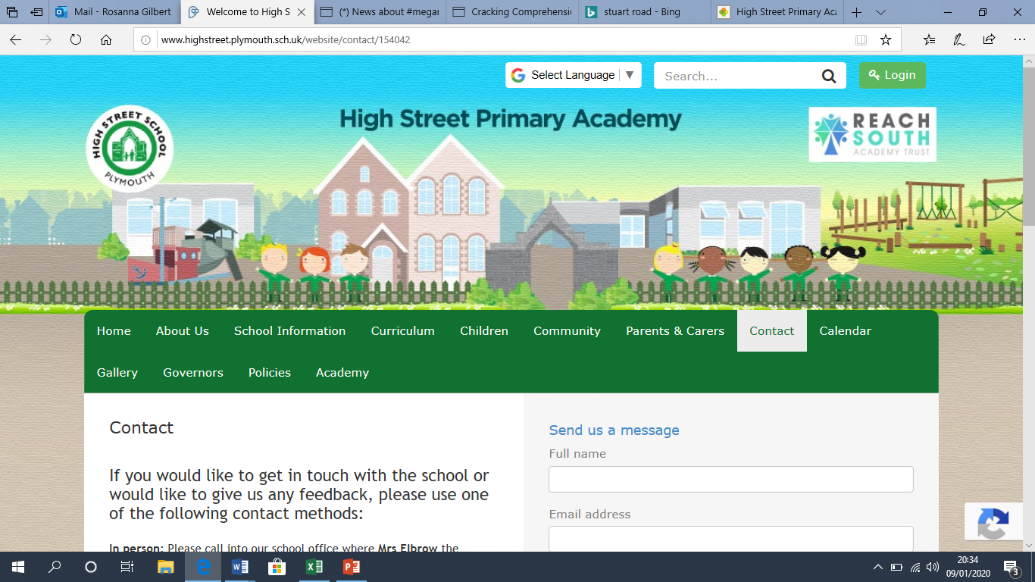**High Street Primary Academy**

**Starfish Class Home Learning WB: 13.04.20**

**We look forward to sharing your completed work in school.**

**Project**

-Choose your favourite jungle animal – draw, paint or create a sculpture of it. You could save your recycling and create a junk model!

-The jungle animals move around in different ways, can you pretend to move like an animal and see if a grown up can guess which one you are?

-Think about some of the noises you could hear in the jungle, write a list!

**English**

**Practice your read, write, inc sounds using the online video clips on the class page. You should know set 1 and set 2 and should be learning set 3. Practice writing words with these sounds. Check the chart on the web page under week 2 learning.**

Over the week, work on creating an information text about a jungle animal. Each day focus on a different heading e.g. what does it eat? How many legs does it have? Where does it live?

Add an image to your fact file and write a caption about it.

Use the internet to find some interesting facts and lots of information!

Spellings this week:

so

little

have

some

where

out

Practice writing these in a sentence e.g. I have a little sister.

**Maths**

**Counting in 10’s**

-How many muffins are there?

-If you had 2 more trays of 10 how many will

there be?

-Create a counting in 10’s number line up to 100! 10 20 30 40 50 ………

-Over the week, practice counting forwards and backwards in 10’s

-If you had 3 trays of eggs with 10 in each, how many eggs will there be?

-You have 50 balloons, each child gets 10 balloons. How many children are there?



**Daily reading**

Read for at least 10 minutes every day! You can access the free eBooks from the links on our class webpage. Talk about what could happen next in your story?

-

Please continue to use the web links on the school class page- these will help children with their learning in a fun and exciting way!