|  |  |
| --- | --- |
| **Vocabulary** | |
| frequency | A measure of how many times per second the sound wave cycles |
| medium | Something which makes possible the transfer of energy from one location to another |
| pitch | How high or low a sound is |
| sound waves | Invisible waves that travel through the air, water and solid objects as vibrations |
| source | Where something comes from |
| transmit | To pass from one place or person to another |
| travel | How something moves around |
| vibrations | Invisible waves that move quickly |
| volume | How loud or quiet a sound is |

Pitch:

High pitch sounds are created by short sound waves.

Low pitched sounds are created by long sound waves.

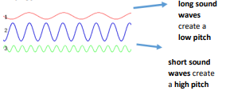

Volume:

The closer you are to the source of the sound, the louder the sound will be.

The further away you are from the source of the sound, the quieter the sound will be.

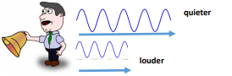

**Diagrams**

|  |  |
| --- | --- |
| **What will I know by the end of the unit?** | |
| How sounds are made | When objects vibrates, a sound is made.  The vibration makes the air around the object vibrate and the air vibrations enter your ear. These are called sound waves.  If an object is making a sound, a part of it is vibrating, even if you cannot see the vibrations. |
| How sounds travel | Sound waves travel through a medium (such as air, water, glass, stone, and brick).  For example, if somebody is playing music in the room next door, the sound can travel through the bricks in the wall. |
| How we hear sounds | When an object vibrates, the air around it vibrates too. This vibrating air can also be known as sound waves.  The sound waves travel to the ear and make the eardrums vibrate.  Messages are sent to the brain which recognises the vibrations as sounds. |
| How sounds change | Pitch:  The pitch of a sound is how high or low it is. A squeak of mouse has a high pitch. A roar of a lion has a low pitch.  Volume:  The volume of a sound is how loud or quiet it is. When a sound is created by a little amount of energy, a weak sound wave is created which doesn’t travel far. This makes a quiet sound. A small tap of a hammer is used with small amounts of energy and so creates a quiet noise.  A vibration with lots of energy makes a powerful sound wave and therefore a loud sound. A powerful, smashing tap of a hammer is used with lots of energy and so creates a loud noise. |

* Hearing is one of your 5 senses

**What should I already know?**