|  |
| --- |
| **By the end of this mini-mission, children should**  **Know...Remember...Understand...Do...** |
| What is the water cycle?  What are the key stages of this process? What is a water source and where is it? How does this link to hills and mountains? How are rivers formed?  What are the main features of a river? What is erosion?  Where do rivers lead to?  Can you name and identify all the seas and oceans? How is marine life affected by plastic pollution?  What is plastic pollution?  What steps can we take to reduce plastic pollution?  How can you communicate your findings geographically?   |  |  | | --- | --- | | Pre-topic score: | Post-topic score: | |  |  | |

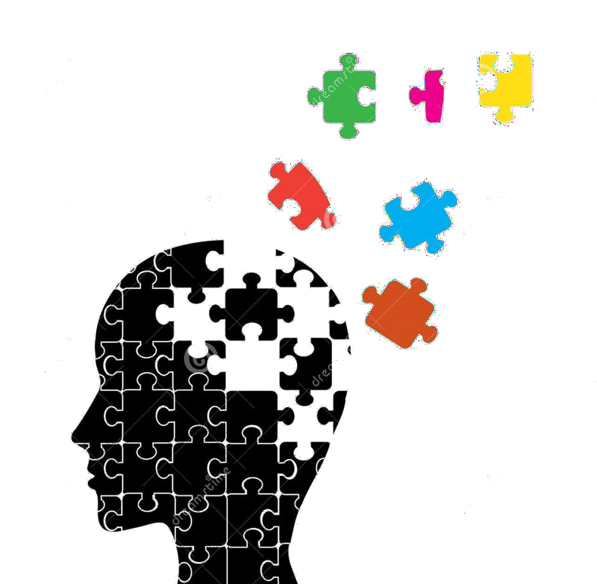

**The Big**

**Question**

**?**

Fieldwork & Skills

Locational Knowledge Place Knowledge

Human & Physical Features

**Who Pays The**

**Price?**

**Geography**

**Y4**

|  |  |
| --- | --- |
| **Key Vocabulary** | |
| water cycle | erosion |
| similarity | silt |
| difference | source |
| topographical | process |
| river | natural |
| mountain | resource |
| coast | stream |
| Northern | pollution |
| Southern | marine |
| hemisphere | devastating |
| longitude | impact |
| latitude | reduce |
| Equator | responsibility |
| continent | communicate |
| digital | geographically |
| evaporation | oxbow lake |
| precipitation | meander |
| condensation | estuary |
| collection | tributary |

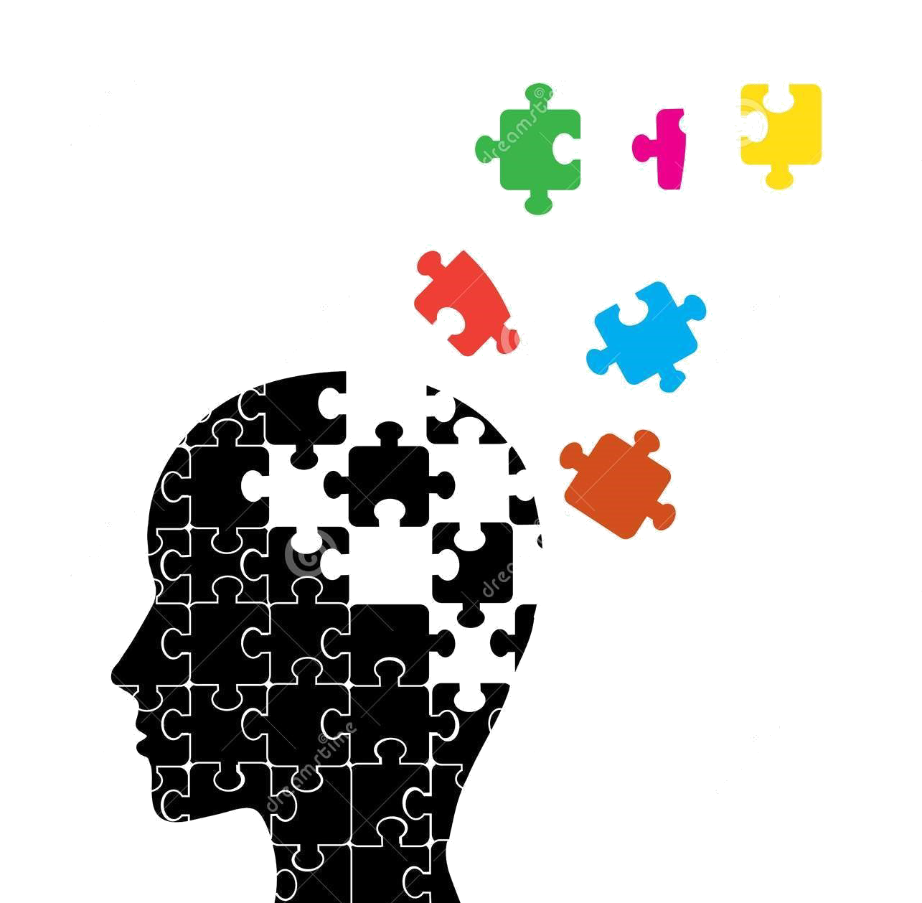

**The Big Question**

**?**

Evaluate Technical Knowledge

Design

Make

**Who Pays The**

**Price?**

**D&T**

**Y4**

|  |
| --- |
| **By the end of this mini-mission, children should**  **Know...Remember...Understand...Do...** |
| When designing your product, what was important to you? How did you use research to inform your ideas?  Did you follow your design criteria?  How did you evaluate the effectiveness of your product?  How did you ensure to make your product functional and appealing?  Why were the aesthetics of this product important? Is your product marketable?  Who is the intended user / audience?  How did you select the correct equipment / tools and materials?  Did you have to amend your design? If so, how?  What was difficult / easy about the design process? |

|  |
| --- |
| **Key Vocabulary** |
| material |
| component |
| aesthetic |
| product |
| marketable |
| effectiveness |
| design |
| criteria |
| equipment |
| design |
| functional |
| appealing |
| purposeful |
| plastic |
| improve |
| prototype |
| evaluation |
| intended |
| analyse |