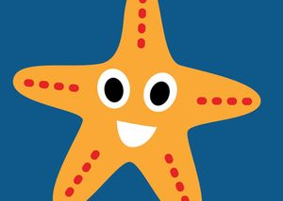
High Street Primary Academy
Starfish Class Home Learning WB: 06.04.20
We look forward to sharing your completed work in school.
Daily reading
- Read for at least 10 minutes every day! You can access the free eBooks from the links on our class webpage. This week you could look for a book about Easter! Also read the books school have provided. Repeat these so your child can build on their reading fluency.
-

Project
- Make an Easter card for your family
- Design an Easter egg!
- Have a go at making Easter rice crispy cakes!

Spellings this week:

go
into
was
he
she

Practice writing these in a simple sentence e.g. I go to the shop.
English

Please continue to use the web links on the school class page- these will help children with their learning in a fun and exciting way!

Maths
- We have been looking at 2D shapes in school. (Circle, square, rectangle and triangle) Can you go on a shape hunt around the house? Make a record of all of the things in your home that are these shapes. Can you draw a shape picture? You could draw yourself with a circle head, rectangle body and tringle hat etc.

Practice your read, write, inc sounds using the online video clips on the class page. You should know set 1 and set 2. Check the chart on the web page under week 2 learning.
-Share your favorite story with someone at home.
-Tell them why it is your favorite? Is it because of something that happens? Or is it because you like a character? It could even be because it is funny!
Choose your favorite character from the story! Draw the character and label it with describing words.

