

Dear Parents/Carers,

Welcome back to the new term! We hope you had a lovely week with your children and they are rested and ready for probably the busiest term of the year. We have lots planned for this term, starting today with Anti-Bullying Week. In assemblies and classrooms this week the children will be thinking about how we can stop bullying from happening at High Street. Clubs will be starting next week so if you would like your child to attend a club until the end of term please make sure they return the slip by the end of this week. Letters about clubs will be going out this Wednesday.

Mrs L. Scott

**The High Street News 02/11/15**

**Parents Questionnaire 2015**

As you know we are always trying to improve our school. To do this well it is important for you to tell us your views about aspects of how the school runs. We greatly value your views about our school. A copy of this questionnaire can also be found on the school website in the parents section, which you will able to print off and complete if you prefer.

We will use your questionnaire results to inform our decision-making processes. Once we have collected all the information together you will receive feedback on the results before the end of the Christmas term.

I would really appreciate it if you could fill in the attached questionnaire and return it to the school office by Monday the 9th of November.

If you have any questions about this please ask to see me via the school office.

**Term Dates (Please check the school calendar on the website)**

**Anti-Bullying Week** 2nd – 6th November

**Fire Safety Talks for year 2 and 5** – 3rd November

**Year 5 into Film Festival** - 5th November

**Open the Book assembly** - 10th November

**SEND Schools Football Competition at Goals** -11th November

**Year 3 and 4 Indoor Athletic Competition** - 18th November

**Eye Tests for Foundation 2 class** - 30th November

We are encouraging the children to do the following things if they are feeling that they may be being bullied in or out of school:

* Tell someone at school and at home
* Don’t stand by and watch it happen

We will be explaining that bullying is REPEATED occasions when a child is INTENTIONALLY hurt

In all schools incidents may happen that will not be classed as bullying as they are not repeated. These incidents will still be dealt with and all children must tell an adult if they need help.

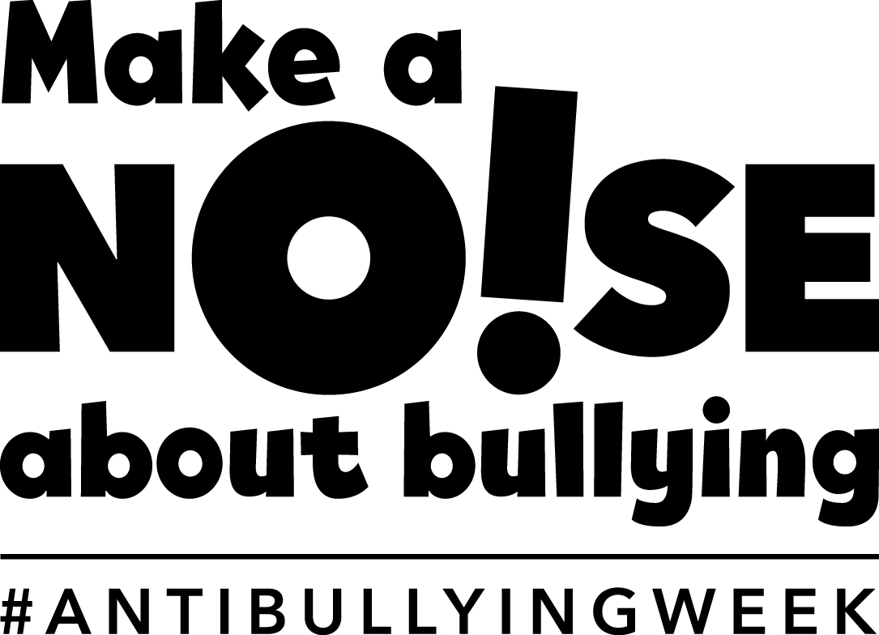

**Our new school website is here!**

I am really excited to write about our new school website. We have totally changed the way the information has been presented so that you can find all the information you need at the click of a button. Each class has their own page and children will start to fill the pages with photographs to show you what they are learning about in class. The teacher will also post important news and information regularly on the website so please do keep checking so you don’t miss anything.