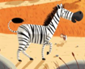
High Street Primary Academy Year 2
Project Overview
Hook
The animals from the safari park have managed to gain plenty of visitors with their purple zebra but poor zebra is fed up with eating beetroot. He needs to think of new vegetables and flowers to grow to get even more visitors.

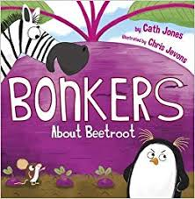
Art / Design
- Safari silhouette pictures
- Clay animals
- Hand print feather parrots
- http://sorozatmania.com/art-and-craft-printables/best-20-safari-crafts-ideas-on-pinterest-hand-print-animals-within-art-and-craft-printables
- Learn to draw safari animals:-
- https://diyunlimitedfun.wordpress.com/2016/07/11/learn-to-draw-african-animals/comment-page-1/
- African patterns

English
- Write lists of vegetables and / or flowers to be grown and equipment needed.
- Write a non – chronological report about safari parks using research.
- Rewrite own version of story using a different vegetable / flower to encourage visitors to the park.
- Invitations – invitations to the safari park event.
- Recount – a newspaper recount about the purple zebra.
Science
- Grow vegetables and flowers
- Observe and describe how plants need water, light and a suitable temperature to grow and stay healthy.
- Learn about processes of reproduction and growth in plants.
- Work scientifically by observing and recording the growth of plants as they change over time from a seed to a bulb.
- Comparative test to show what plants need to stay healthy.

Humanities
- Name and locate the 7continents of the world and 5 oceans – locate Africa and link to the story. (Twinkl – label sheet)
- Weather patterns in Africa
- Use world maps to locate Africa.
- Vegetation and physical features of Africa.
- Human features of Africa

High Street Primary Academy Year 2
Project Overview
Music
- Djembe drumming
- African drumming patterns
- Learning African sounds
- African instruments
PE
- Animal yoga – Twinkl prompt cards
- African dance moves
Maths
- Measuring and recording growth of plants.
- Safari word problems
- Jungle and safari pictograms

