****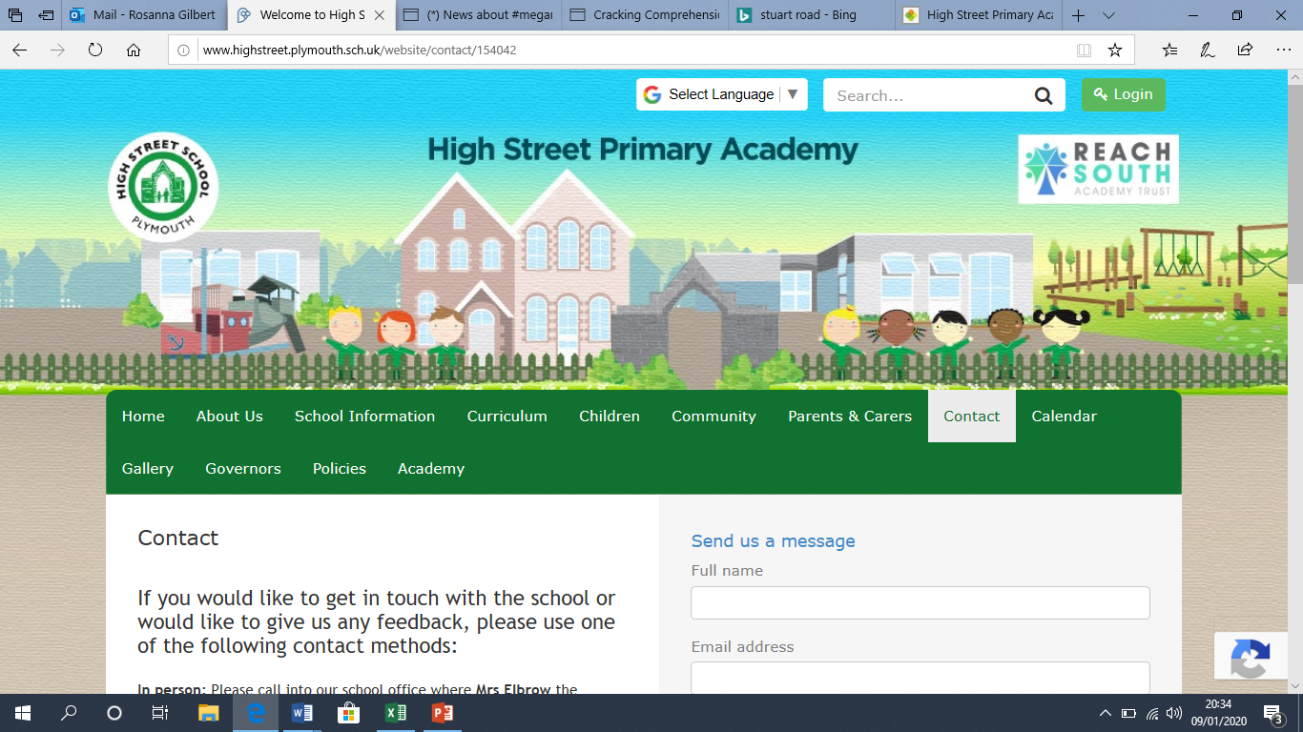**High Street Primary Academy**

**Starfish Class Home Learning WB: 13.04.20**

**We look forward to sharing your completed work in school.**

**Project**

-Draw or paint a picture of some flowers. What colours do you need? Can you remember the different parts of a flower? Try and use the words stem, leave, petal and roots to describe your flower.

- Try growing a plant or flower at home. You could plant a seed in a pot!

**English**

Spellings this week:

we

me

be

you

all

Practice writing these in a simple sentence e.g. I go to the shop.

**Practice your Read, Rrite, Inc sounds using the online video clips on the class page. You should know set 1 and set 2. Check the chart on the web page under week 2 learning.**

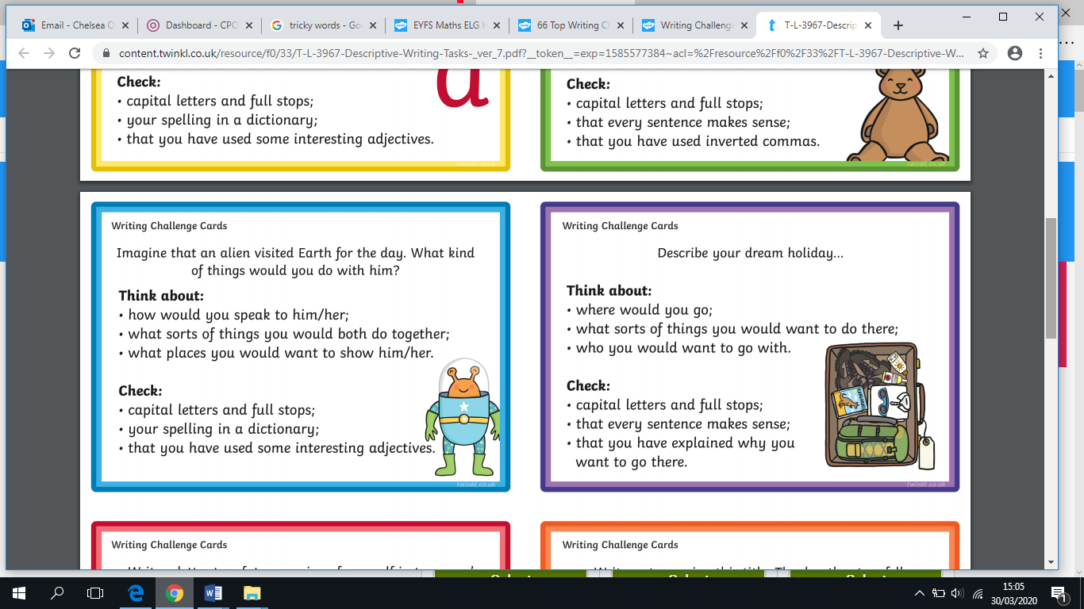

**Maths- sharing**

Over the week, have a go at sharing things with your family or teddies! Our new maths vocabulary this week: **Equal, Share, same, fair**

-Share 10 biscuits with 2 of your teddies- How many will they have each?

-Share 15 toys with 3 of your teddies- How many do they have each?

-Share 12 sweets with 4 of your family members- How many will they have?

-What happens if you share 10 biscuits with 3 people? Is this fair?

-What else can you share this week?

**Daily reading**

*-* Read for at least 10 minutes every day! You can access the free eBooks from the links on our class webpage. Also read the books school have provided. Repeat these so your child can build on their reading fluency.

-

Please continue to use the web links on the school class page- these will help children with their learning in a fun and exciting way!