****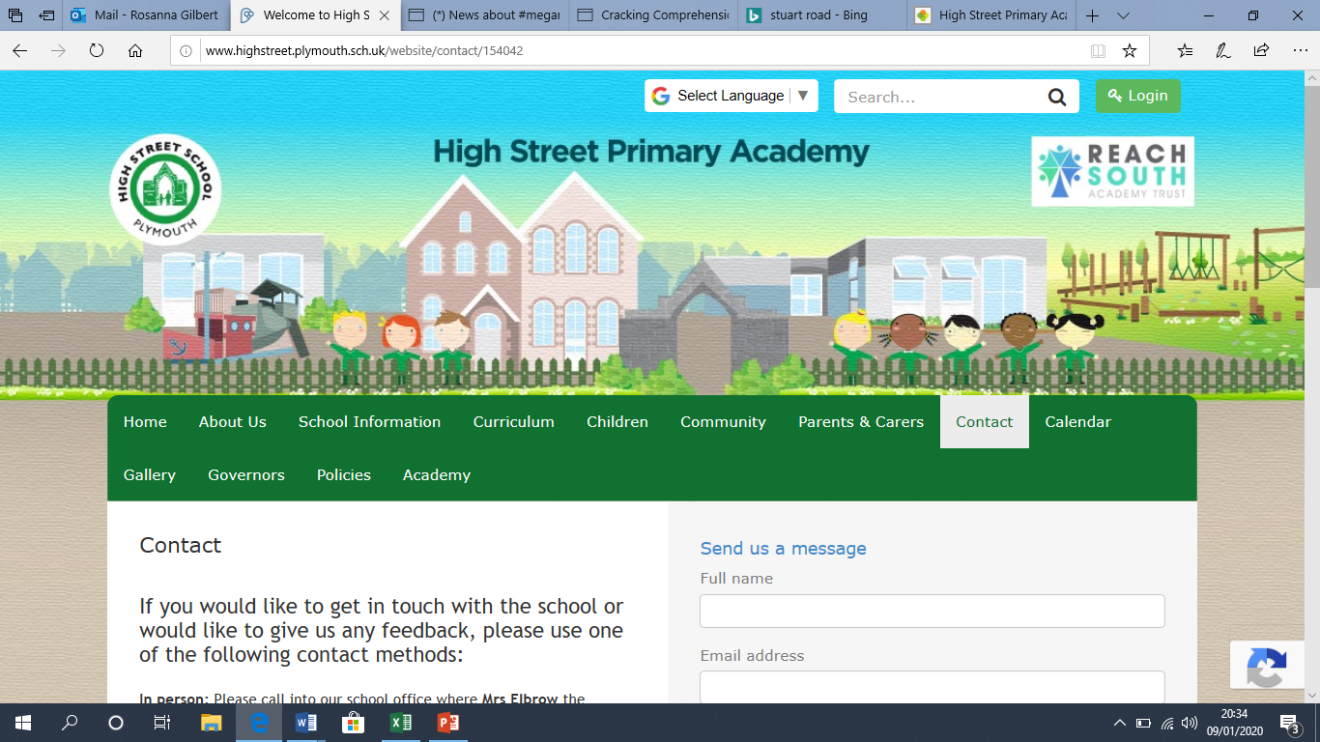**High Street Primary Academy**

**Starfish Class Home Learning WB: 30.03.20**

**We look forward to sharing your completed work in school.**

Practice your read, write, inc sounds using the online video clips on the class page. You should know set 1 and set 2 and should be learning set 3.

* Do some baking or make a sandwich. Write instructions for how to do it.
* Continue to keep a diary about your days. What time did you wake up? What did you have for lunch? What games did you play?

**Project**

Research a mini beast of your choosing. This could be a butterfly, ladybird, beetle or spider. There are many to choose from. You could paint a picture/ make a model or create an observational drawing. You could find facts about the mini beast and make a fact page!

Please continue to use the web links on the school class page- these will help children with their learning in a fun and exciting way!

Spellings this week:

he

she

we

me

be

you

Practice writing these in a sentence e.g. We went to the park.

**English**

**Maths**

-How many ways can you make 15? Can you write the different number sentences in your exercise book? You could use small objects to help. Start with 15, separate them into 2 groups and the write the number sentence. E.g. 10+5=15

- Roll the dice game. Roll a dice, how quickly can you find one more and one less of that number? Write the number sentence in your book. E.g. 6+1=7 6-1=5 if you would like a challenge, roll 2 dice together, add the 2 digits together and then find one more and one less. (You download a dice app online if you don’t have one at home)

**Daily reading**

*-* Read for at least 10 minutes every day! You can access the free eBooks from the links on our class webpage.

-